Murton Cricket Club
Welfare Ground, Murton, Seaham Co. Durham SR7 9RD
Tel: 0191 5268136
Web: www.murtoncc.com E-Mail: murtoncc@hotmail.co.uk or ian.graham1@hotmail.co.uk

COVID RETURN TO CRICKET STEP 4 INFORMATION
SENIOR CRICKET

The below guidance has been developed by Murton Cricket Club (CC), in-line with ECB return to cricket plan step 4, and is club specific. All other adaptions as specificed in the ECB Guidance apply.

Before Activity

- Please be aware that Murton CC Pavilion is ran and operated by Murton Welfare Association. The Pavilion including Bar and changing rooms will be closed. Toilet facilities will be provided on a one-at-a-time basis and will be clearly signposted.
- No tea or refreshments will be available – each player and official should bring along their own hand sanitiser (although Hand Sanitiser will be available at the ground) and any food and drink that they require (including enough water to last for the game).
- The COVID Return to Cricket Risk Assessment for Murton CC is available on the club website (www.murtoncc.com) and each Murton CC senior captain has a copy.
- Please provide a single point of contact to Murton CC Fixture Secretary Alan Welburn (awelburn@hotmail.co.uk) and or Club Secretary Ian Graham (ian.graham1@hotmail.co.uk) so that contact tracing can be carried out if necessary in line with NHS England requirements. Visiting clubs will need to keep a register of all their participants (players and officials) in-line with ECB Guidance.
- For spectators and visitors, a login register will be sited at the Main gates entrance of Murton CC and we respectively request all visitors enter details again for contact tracing, should the need arise, in line with NHS England requirements.
- Please note Murton CC car park inside ground perimerter will be closed to all vehicles unless blue badge holders. We respectively request you park cars outside ground in a safe and sensible manner.

During Cricket Activity

- Teams should arrive no earlier than 30 minutes before the start of the game.
- An area to the right of the pavilion and infront of the car park, when viewed from the square will be made available for the visiting team to pad-up (please see diagrams below):
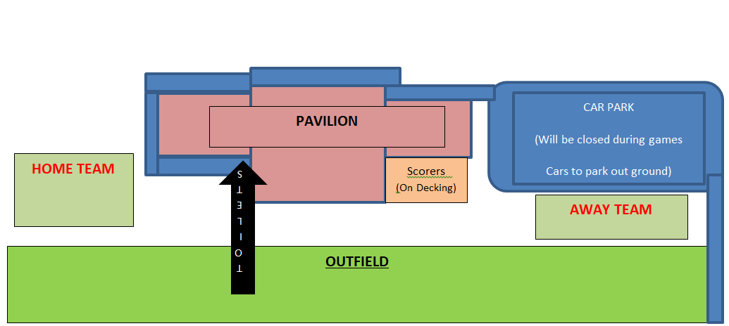

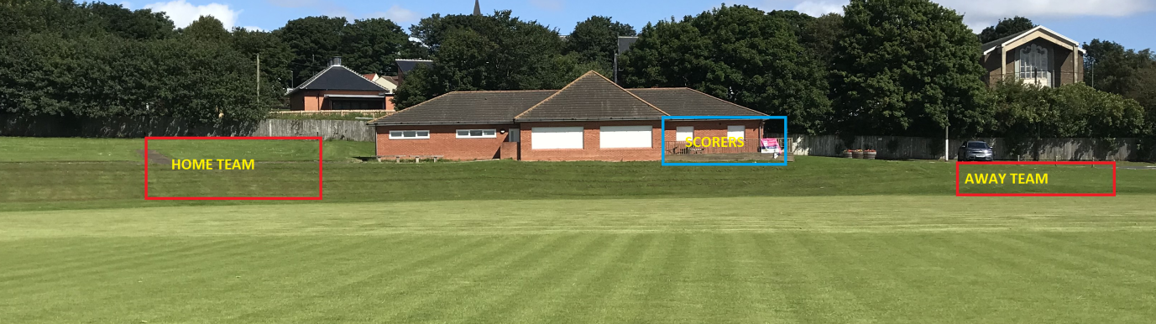

- The visiting team warm-up area is on the outfield to the right of the pavilion, in front of the car park, when viewed from the square.
- Players should remain socially distanced at all times during play (wicket keepers and slip fielders at 1 m+)
- A socially distanced scoring station for one scorer per team will be set-up and located on the decking section of the pavilion located on the right side of the pavilion as viewed from the square. In the event of the scoring station being impaired by sight screens, a different socially distanced and secure area will be advised to the visiting team and officials upon arrival.
- The pitch will be marked up for running as per ECB guidance.
- In the event of rain, participants should return to their vehicles whilst maintaining social distancing guidance.

During Cricket Activity

- Unfortunately, Murton CC pavilion is currently closed and as such the bar is not open after the game.
- Please exit the ground whilst maintaining social distancing, esuring you have taken all your equipment.
- In respect to Murton Welfare Association, we respectively request that you take all rubbish away with you or dispose of in waste bins inside ground.

This guidance was accepted by the Murton CC executive committee on 20th July and will be reviewed and adapted by Murton CC Executive committee accordingly in line with any changes to guidance submitted by ECB and,or Government.

